Braille Character Recognition Using Image Processing

**Bhoomika P¹, Mithun Raj S R², Aadin Anayodan3, Anjali C S4, Sailaja Thota5**

1,2,3,4,5School of Computer Science and Engineering, REVA University,

Bangalore, Karnataka, India.

[bhoomikapathapati@gmail.com](mailto:bhoomikapathapati@gmail.com)1, [mithunraj046@gmail.com](mailto:mithunraj046@gmail.com)2,

[aadindev@gmail.com](mailto:aadindev@gmail.com)3, [asshettysrinivas@gmail.com](mailto:asshettysrinivas@gmail.com)4, [sailaja.thota@reva.edu.in](mailto:sailaja.thota@reva.edu.in)5

**Abstract –** Braille characters are designed for the visually challenged which consist of six embossed points arranged in a standard character format. Finger sensitivity is crucial in reading Braille characters by touch, and learning them can be challenging as they need to be memorized. The present work aims to use image pre-processing techniques such as cropping, grayscale conversion, thresholding, erosion, and dilation to process Braille character images. These processed images will then be subjected to image processing and optical character recognition (OCR) methods to recognize the Braille characters and convert them into alphanumeric text. The implementation of this innovative idea could have a significant positive impact on the creation of educational materials for individuals with visual impairment and other related applications.

**Index Terms *–*** Braille, grayscale, thresholding, erosion, dilation, image processing, OCR(Optical Character Recognition).

1. **INTRODUCTION**

The Braille system was invented to aid visually impaired individuals in reading and writing. However, there are still challenges associated with recognizing and translating Braille characters to understandable text. Braille characters are typically composed of six dots arranged in a rectangular grid of two dots wide and three dots in vertical column. Therefore, the system will need to accurately identify and separate the individual dots or dot patterns representing the Braille characters. The proposed system makes use of Image Processing and Optical Character Recognition (OCR) techniques to accurately recognize Braille characters from images.

People with vision impairments frequently read and write using the Braille system. It appears as a collection of raised dots that can be read with touch perception. Anyone who is not blind or visually impaired can read the Braille pattern. The Braille character can be specified in any language, including English, even though Braille is a code rather than a language. Within a predetermined area known as a Braille cell, the Braille symbols (which correspond to alphabets) are formed. The points where dots are elevated, which are uniformly numbered 1 to 3 from top to bottom in the left column and 4 to 6 from top to bottom in the right column, can be used to describe a specific combination. For instance, dots 1- 3-4 show a cell with three raised dots at the top, bottom, and top of the right column, which corresponds to the English letter m in the binary vector [101100].

The proposed framework will enable better accessibility to Braille literature and increase independence and literacy among visually impaired individuals. The approach used in this work involves pre-processing the input image, segmenting the Braille characters, and applying OCR techniques to recognize the characters. The proposed system will provide a user-friendly Graphical User interface (GUI), enabling easy and efficient conversion of Braille text into conventional text. The results of thi work will have a significant impact on the visually impaired community and promote inclusive education and equality.

1. **LITERATURE SURVEY**

A user-friendly smartphone app was developed by Ab Wahab et al. (Ab Wahab et al. 2021), specifically for those with visual impairments. The optical character recognition (OCR) framework's image-to-text conversion feature was then used to transform the acquired image to text. The volume down button on a smartphone, which is easily located by touching, can be used by a visually challenged person who to take a picture or they can allow the picture be taken automatically.

Dalip, Filiz et al. (Dalip et al. 2022) developed a device that utilizes Optical Character Recognition (OCR) and Speech Recognition algorithms to convert printed materials into Braille alphabet for visually impaired individuals. This device aims to provide faster access to written culture and make documents, articles, and other products more accessible for visually impaired individuals.

A design proposal for a low-cost braille printer that uses OCR technology (Optical Character Recognition) was presented by Encinas et al. (Encinas et al. 2019), through a mobile application with an algorithm that allows identifying text and images for braille translation or tactile embossing.

Falcon et al. (Falcon et al. 2005) proposed an approach for the creation of BrailLector, a system that can speak Braille writing using dynamic thresholding, an adaptable Braille grid, recovery dots, and text-to-speech software.

The fundamentals of an optical character recognizer (OCR) for the Braille Code, the writing system used by the blind, are described by Hermida et al. (Hermida et al. 1996). The finished system is a polished Windows application that functions as a standard text OCR and is quite appealing to blind people (in fact, they supported the project).

The process of converting Devanagari Hindi Braille first to text, then to voice has been examined by Kaur et al. (Kaur et al. 2020). Lu, L et al. (Lu, L et al. 2022) proposed a novel approach for Braille character detection based on edge features, taking into account the small size of Braille characters in natural scene images. A data set called NSBD was created, which consists of natural scene Braille images. Mithe, R et al. (Mithe, R et al. 2013) created an intuitive application for Android phones that conducts image to speech conversion.

The fundamental concept proposed by Nag et al. (Nag et al. 2020) is the creation of a text-detection system for blind persons. The camera module attached to the Raspberry Pi allows the blind to interpret text from images without assistance from a human. Patel et al. (Patel et al. 2015) proposed an approach that focuses on Gujarati Braille script for identifying braille characters. It also emphasizes conversion techniques and focuses on a variety of material for translating Braille into multiple languages.

A sample of the OCR tools that are accessible and instruct students on how to use the Tesseract tool, which is transcribed in either Latin male or female was developed by Sharma et al. (Sharma et al. 2022). Using the device learning concept, this paper aims to provide OCR software that recognizes text characters. Shinde et al. (Shinde et al. 2012) addressed a novel profile-based method for segmenting printed text that divides the text in document images into lines, words, and characters, as well as an algorithm for correcting the skew angle formed during scanning of the text document.

In order to recognize Cyrillic alphabet letters in the Braille representation system, an artificial neural network was developed by Smelyakov et al. (Smelyakov et al. 2018). The network will receive training and testing for reading Braille that contains scanned Cyrillic letters. Subur et al. (Subur et al. 2016) converted the Braille characters into alpha-numeric text and then developed a method for recognizing them using find contour and artificial neural networks.

1. **METHODOLOGY**

The proposed system takes an input from a camera or a scanned image of a braille text, then converts it into English text using OCR technique. The extracted text is further converted to speech using TTS (Text-To-Speech) software as shown in Figure 1 and 2.

The complete procedure for Braille pattern recognition is divided into two steps i.e. Pre-processing and Pattern recognition.

3.1 Pre-Processing Steps

* Scanning of the Braille code - a digital image of the Braille characters is captured using a scanner or a camera, and image processing algorithms are used to analyze the image and determine the arrangement of dots.
* Conversion of RGB image to binary image - Thresholding is a simple and commonly used technique for converting an RGB image to a binary image. If the intensity value of a pixel is higher than the threshold, it is set to white (1), otherwise, it is set to black (0).
* Removal of the impulse noise and unwanted big dots - Mathematical morphology is a set of image processing operations that can be used for various tasks, including noise removal. Operations such as erosion and dilation can be used to remove small isolated noise pixels or fill in gaps in larger dots.
* Resizing of the binary image - Morphological operations, such as erosion and dilation, can be used for resizing binary images. Erosion can be used to shrink or downscale a binary image, while dilation can be used to expand or upscale a binary image.
* Complementing the image (bit 1 to 0 and bit 0 to 1) - Many image processing libraries, such as OpenCV, provide built-in functions for image complementing.
* Removal of the unwanted redundant edges of the image - Morphological operations, such as erosion and dilation, can be used for image edge pruning. Erosion is a morphological operation that can be used to shrink or thin edges in an image by iteratively removing pixels from the edges of objects. Dilation, on the other hand, can be used to expand or thicken edges by adding pixels to the edges of objects.

3.2 Pattern Recognition Steps

1. Segmenting the Braille Image into lines
2. Segmenting the Braille lines in to alphabet patterns
3. Division of alphabet pattern image in to six equal grids of size 3 x 2. The size 3 x 2 is selected because this is the international standard of the Braille.
4. Counting the number of white pixels in each grid and checking whether it satisfies the threshold criterion.
5. Generation of a pattern vector on the basis of this result in terms of 0’s and 1’s
6. Linking of the pattern vectors with corresponding alphabets

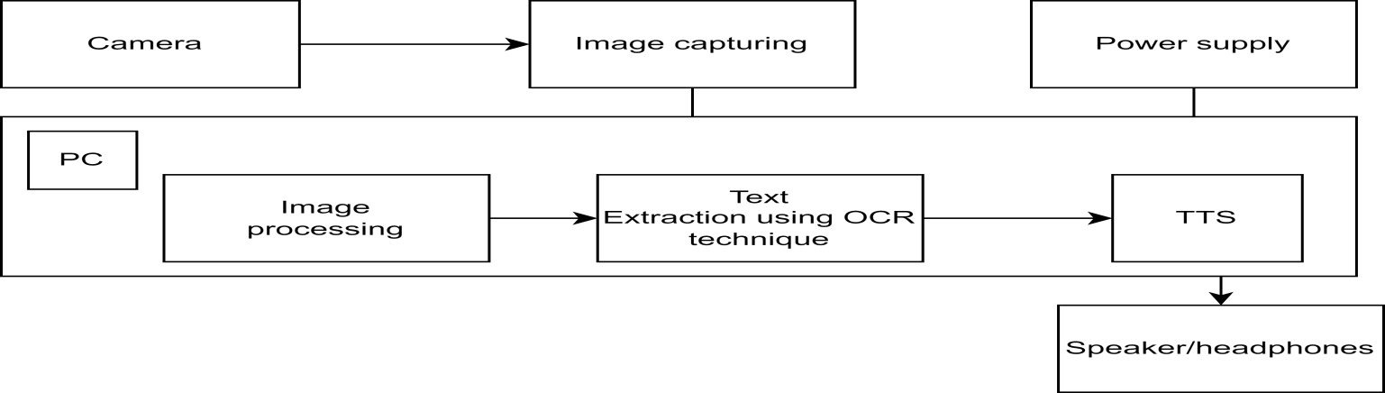

**Figure 1 : Methodology used for Translation of Braille Characters**

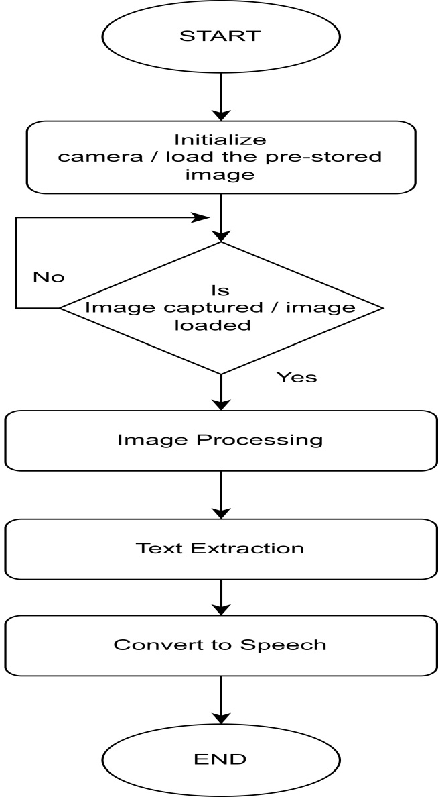

**Figure 2 : Flowchart of the Translation process**

**Image Capturing:** First step is to capture an image from the document or book which is placed under the camera to capture an image from the document or book. The camera used to capture an image is PC camera.

**Image Pre-processing:** Image pre-processing is to remove unwanted noise in the image by applying appropriate threshold. It is used for correcting skew angles, sharpening of image, thresholding and segmentation.

**Text extraction:** The developed system makes use of modules that are used to extract the recognized text. The extracted text is then converted into speech using a text-to-speech synthesizer. Finally, the synthesized speech output is obtained as the end result of the process.

1. **RESULTS**

The proposed framework was able to successfully recognize and convert Braille characters in an image into text using image processing techniques and OCR. The system was tested on various Braille images and obtained accurate results. Graphical User Interface (GUI) based user-friendly system developed, to enable the user to upload an image and receive the corresponding text output as shown in Figure 3. Additionally, text-to-speech functionality is implemented, which allows the user to hear the recognized text as an audio output. Figure 4 represents the input image of Braille character. Upon loading the input image, the image is processed, resulting in the processed image, as illustrated in Figure 5. The processed image undergoes extraction of Braille characters, which are then represented as text for further processing as illustrated in Figure 6.

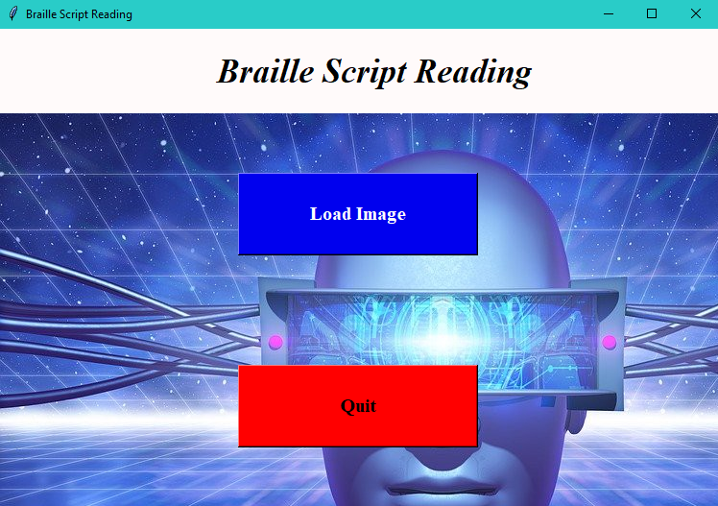

**Figure 3 : Initial GUI after running the code**

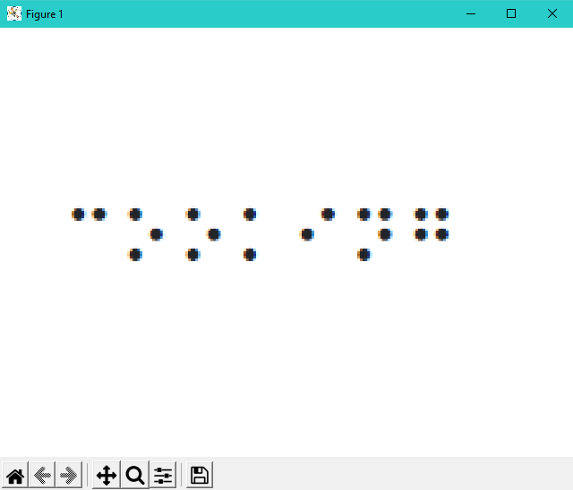

**Figure 4 : Braille Character input image loaded**

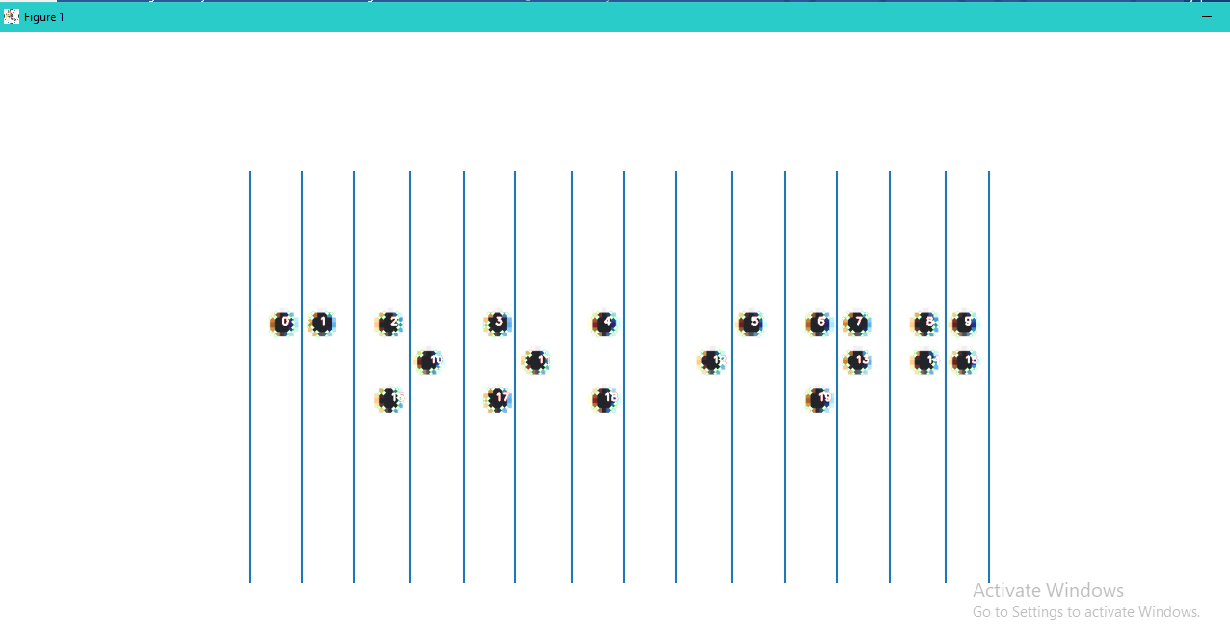

**Figure 5 : Segmented Image**

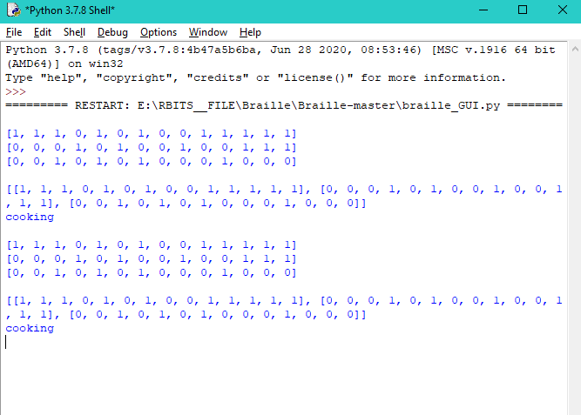

**Figure 6 : Output**

Overall, the findings and results show that the system is effective and efficient in recognizing Braille characters and converting them to text. Currently, the proposed system focuses on recognizing Braille characters in a specific language. As a future work, the system could expand to support multiple languages, as Braille is used in various languages around the world. This can involve training the OCR algorithms on diverse Braille character datasets from different languages and incorporating language-specific features and patterns.

1. **CONCLUSION**

In conclusion, our Braille character recognition work successfully achieved its objective of recognizing Braille characters in an image and converting them into text using image processing techniques and OCR. GUI and text-to-speech functionality has been added to improve user experience and accessibility. The developed system has the potential to make a significant impact on the visually impaired community by providing an efficient and accurate method of recognizing Braille characters. It can also assist in digitizing and preserving Braille literature, which would make it more widely available and accessible to those who rely on Braille for reading and writing. In future, this work can be extended to multiple languages.

**REFERENCES**

Ab Wahab, M. N., Mohamed, A. S. A., Sukor, A. S. A., & Teng, O. C. (2021, February). Text reader for visually impaired person. In Journal of Physics: Conference Series (Vol. 1755, No. 1, p. 012055). IOP Publishing.

Dalip, F., YILDIZ, K., ÜLKÜ, E. E., & BÜYÜKTANIR, B. Raspbraille: Conversion to Braille Alphabet with Optical Character Recognition and Voice Recognition Algorithm. Hittite Journal of Science and Engineering, 9(4), 253-261.

Encinas, I. D., Bringas, J. A. S., Verdugo, A. I. D. C., Bringas, C. S., & Muñoz, J. G. S. (2019, October). Low-cost Braille printer prototype design with OCR technology. In 2019 International Conference on Inclusive Technologies and Education (CONTIE) (pp. 205-2054). IEEE.

Falcón, N., Travieso, C. M., Alonso, J. B., & Ferrer, M. A. (2005). Image processing techniques for braille writing recognition. In Computer Aided Systems Theory–EUROCAST 2005: 10th International Conference on Computer Aided Systems Theory, Las Palmas de Gran Canaria, Spain, February 7–11, 2005, Revised Selected Papers 10 (pp. 379-385). Springer Berlin Heidelberg.

Hermida, X. F., Rodriguez, A. C., & Rodriguez, F. M. (1996). A Braille OCR for Blind People. Proceedings of ICSPAT-96. Boston (USA).

Kaur, P., Ramu, S., Panchakshari, S., & Krupa, N. (2020, November). Conversion of Hindi Braille to speech using image and speech processing. In 2020 IEEE 7th Uttar Pradesh Section International Conference on Electrical, Electronics and Computer Engineering (UPCON) (pp. 1-6). IEEE.

Lu, L., Wu, D., Xiong, J., Liang, Z., & Huang, F. (2022). Anchor-Free Braille Character Detection Based on Edge Feature in Natural Scene Images. Computational Intelligence and Neuroscience, 2022.

Mithe, R., Indalkar, S., & Divekar, N. (2013). Optical character recognition. International journal of recent technology and engineering (IJRTE), 2(1), 72-75.

Nag, B. H., Nagamani, V., Amarapalli, T. K., Sandhya, R., & Venkatesh, V. V. (2020). DEVELOPMENT OF REAL TIME TEXT RECOGNITION SYSTEM FOR VISUALLAY IMPAIRED PEOPLE.

Patel, N. K., Patel, K. J., Vyas, H., & Solanky, J. (2015). A Review on Gujarati Braille Character Recognition. International Journal of Innovations & Advancement in Computer Science IJIACS ISSN, 2347-8616.

Sharma, S., Kumar, R., Bisht, M., & Singh, I. (2022). Optical Character Reader. In Emerging Technologies in Data Mining and Information Security: Proceedings of IEMIS 2022, Volume 2 (pp. 333-344). Singapore: Springer Nature Singapore.

Shinde, A. A., & Chougule, D. G. (2012). Text pre-processing and text segmentation for OCR. International Journal of Computer Science Engineering and Technology, 2(1), 810-812.

Smelyakov, K., Chupryna, A., Yeremenko, D., Sakhon, A., & Polezhai, V. (2018, August). Braille character recognition based on neural networks. In 2018 IEEE Second International Conference on Data Stream Mining & Processing (DSMP) (pp. 509-513). IEEE.

Subur, J., Sardjono, T. A., & Mardiyanto, R. (2016). Braille character recognition using find contour and artificial neural network. JAVA Journal of Electrical and Electronics Engineering, 14(1).